Color Palette

Medium Blue 1 | #0069f3
Dark Blue 1 | #0035a2
Light Blue 1 | #cbdbff
Dark Blue 2 | #000e3f
Dark Blue 3 | #373c82
White | #ffffff

Logos

LOGO 1 |  | https://drive.google.com/file/d/11kfe6bHp0n0XIazNWrJhaiJxmqV8-JSu/view?usp=drive_link
LOGO 2 | 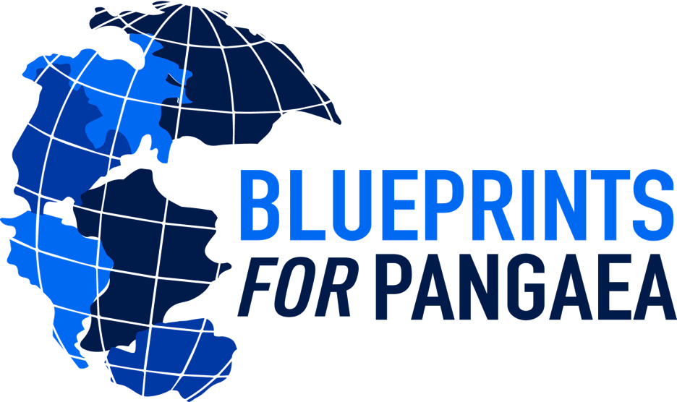 | https://drive.google.com/file/d/1OMy27u7HksI1gaX90REQFtUqyUC1v0zz/view?usp=sharing
LOGO 3 | 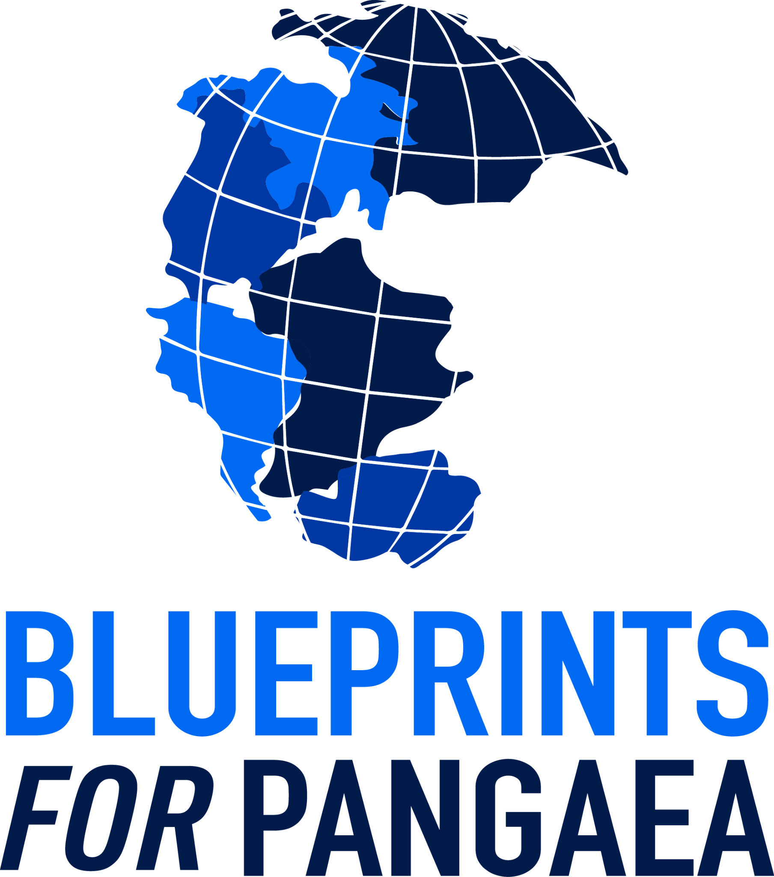 | https://drive.google.com/file/d/1-FZrGphIWugjuveynXMb9wZbgNLvTQS1/view?usp=drive_link
LOGO 4 | 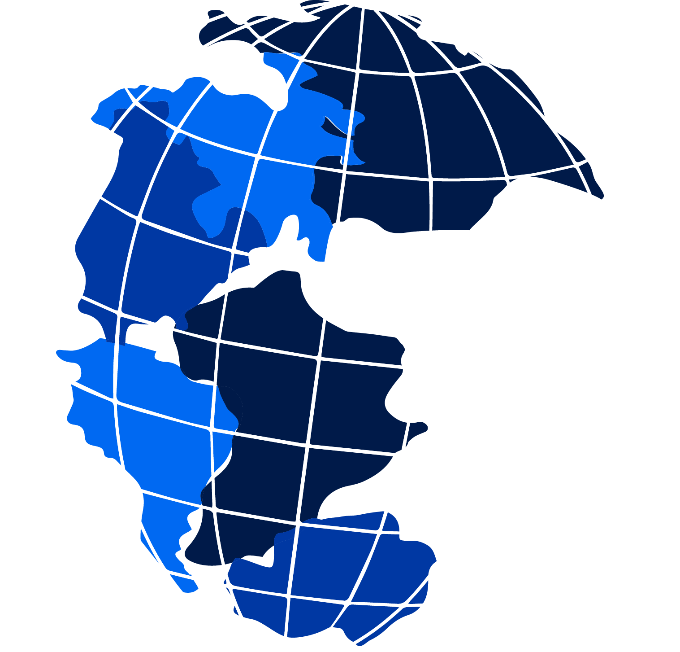 | https://drive.google.com/file/d/1_ZfwzdFPUAS5-8N42BCnT8Sx8vbP-5Uw/view?usp=drive_link
LOGO 5 | 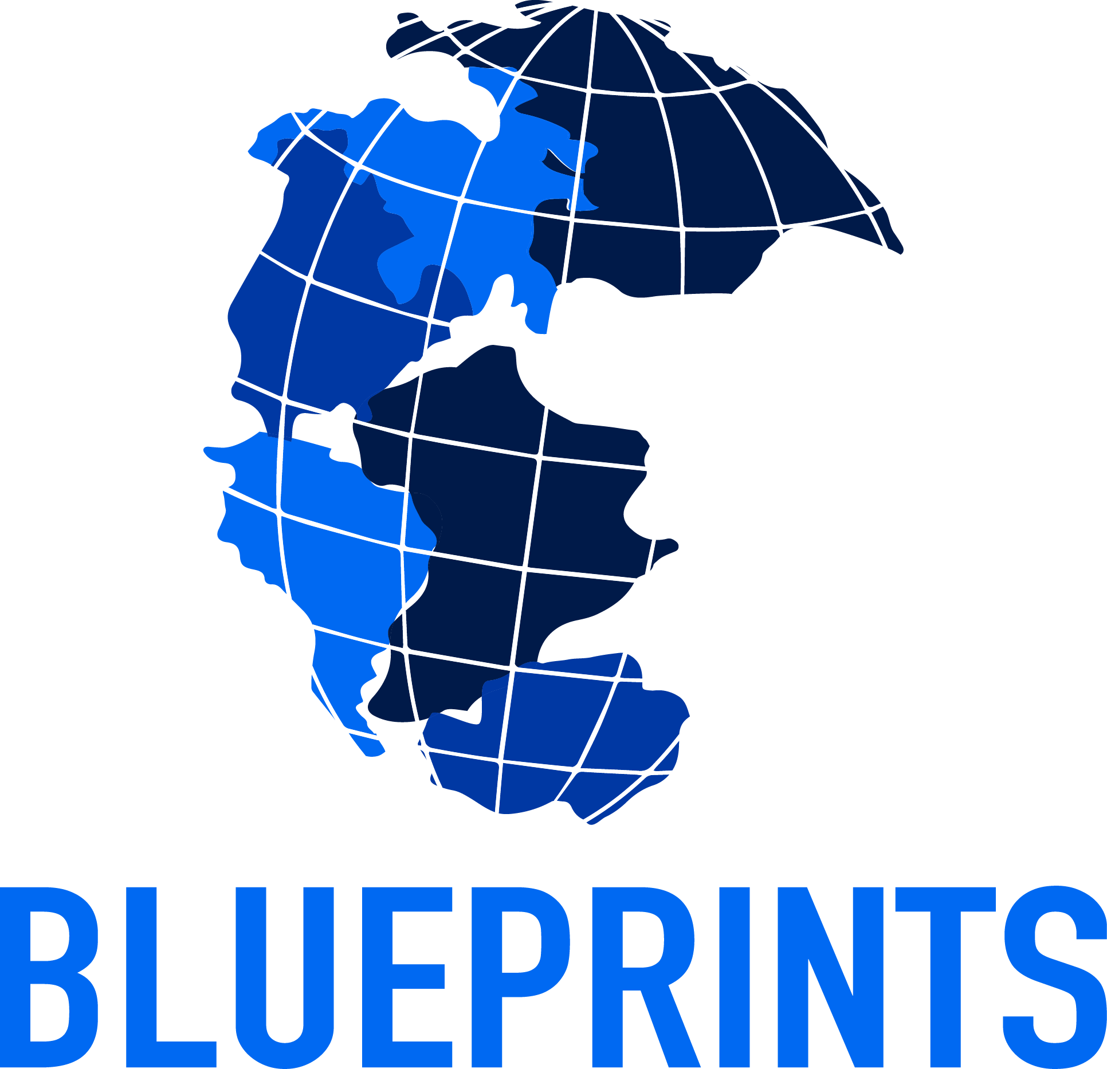 | https://drive.google.com/file/d/1idZfKb-gYzJsu4pPMBg5W4IIWOugRmPF/view?usp=drive_link

